- $f\left(x\right)\vec{T\left[a;0\right]}f\left(x−a\right)$
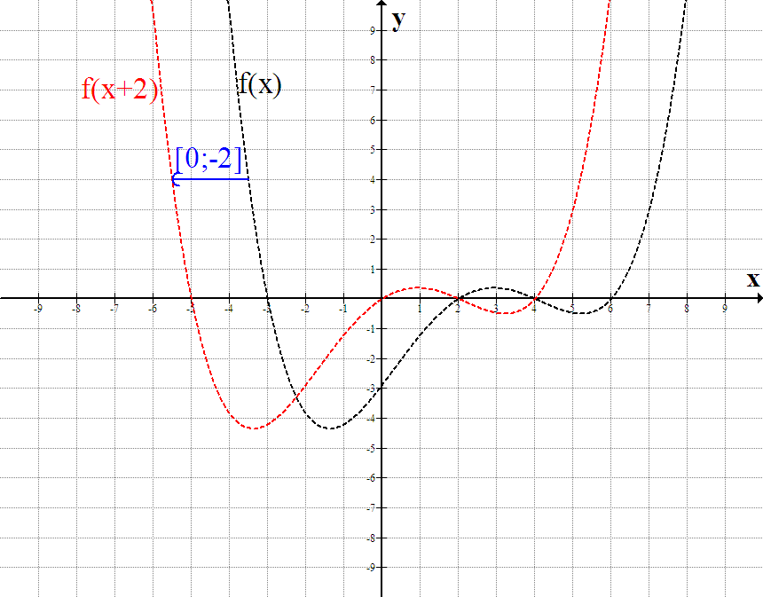
- $f\left(x\right)\vec{T\left[0;b\right]}f\left(x\right)+b$
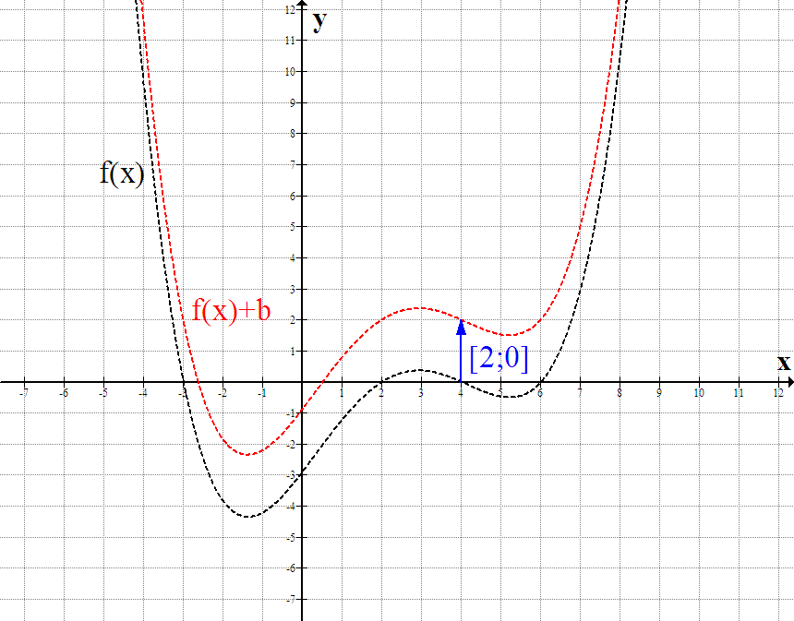
- $f\left(x\right)\vec{\text{Soy}}f\left(−x\right)$
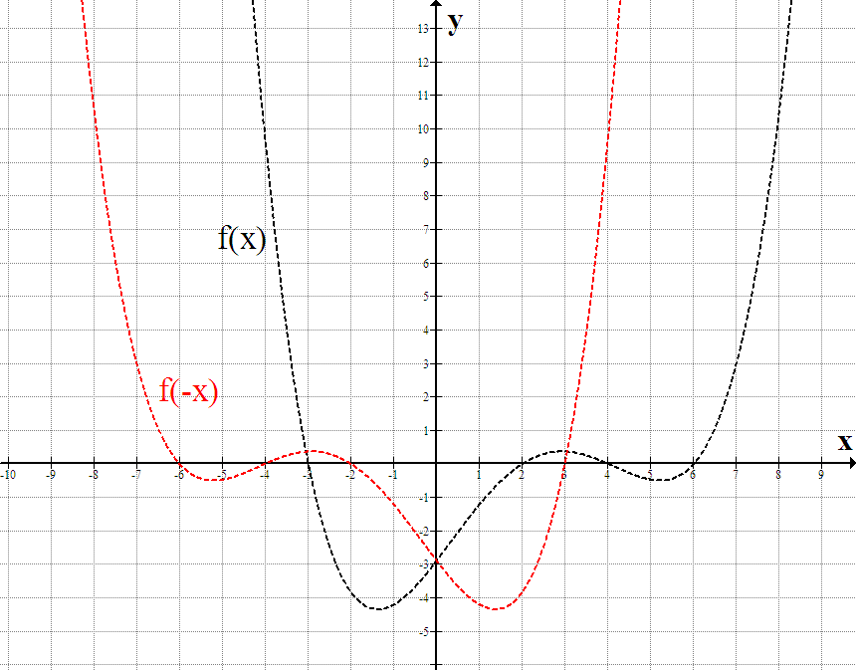
- $f\left(x\right)\vec{\text{Sox}}−f\left(x\right)$
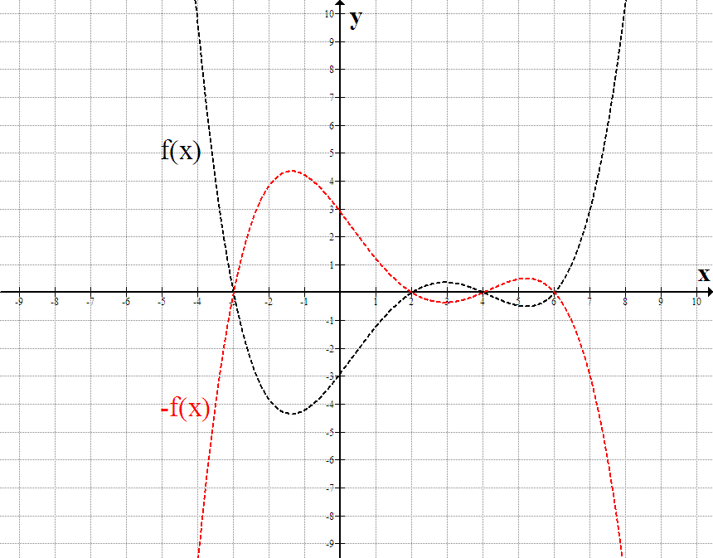
- $f\left(x\right)\vec{\text{Soy} \text{dla} x>0}f\left(\left|x\right|\right)$
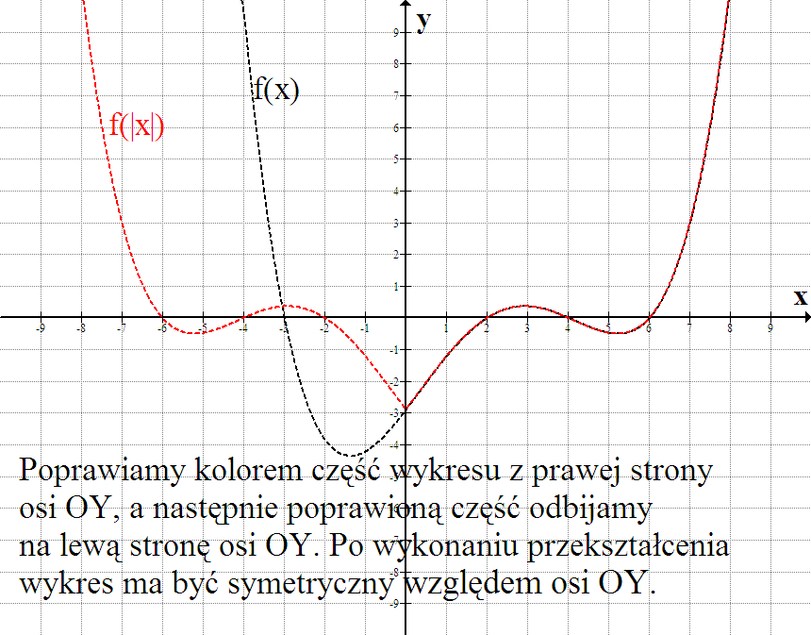
- $f\left(x\right)\vec{\text{Sox} \text{dla} y<0}\left|f\left(x\right)\right|$
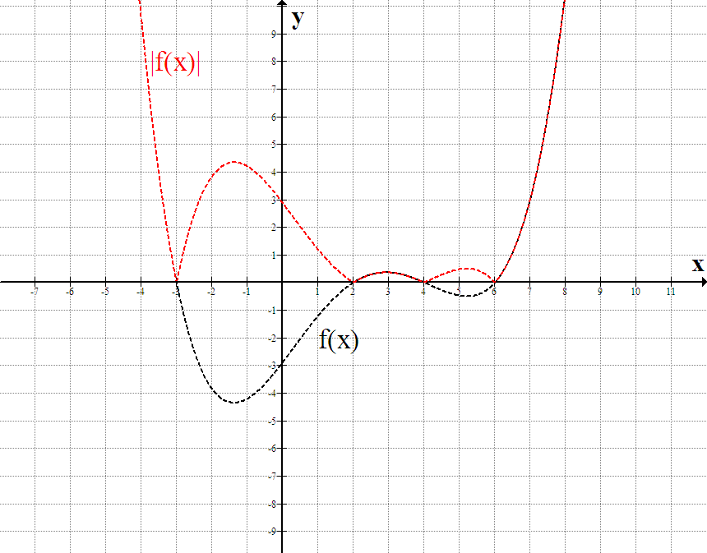

Zadania:
Naszkicuj wykresy funkcji:

$f\left(x\right)=−{\left(\left|2−x\right|−1\right)}^{2}+3$;
$f\left(x\right)=\frac{1}{3−\left|1−x\right|}−2$;
$f\left(x\right)=−\left|\frac{1}{2−\left|x+1\right|}\right|+2$;
$f\left(x\right)={\left(3−\left|x−2\right|\right)}^{3}−2$;
$f\left(x\right)=−\sqrt{\left|x\right|−2}+3$;
$f\left(x\right)=−{\left(\left|2−x\right|−1\right)}^{2}+3$;
$$f\left(x\right)=−{\left(\left|2−x\right|−1\right)}^{2}+3$$
$f\left(x\right)=−2^{2−\left|x−1\right|}+3$;
$f\left(x\right)=\left|x^{2}−2\left|x\right|−3\right|−2$;
$f\left(x\right)=\left(\left|x\right|−2\right)\left(\left|x\right|−4\right)$;
$f\left(x\right)=\left|x^{2}−3\right|−x+1$;
$$f\left(x\right)=\left|\text{log}(x+2)−1\right|−2$$
$f\left(x\right)=\begin{aligned}\left\{{\left(\frac{1}{2}\right)}^{x}−2^{\left|x\right|} \text{dla} x<0 | \right.\end{aligned}$;
$f\left(x\right)=\left|4−x^{2}\right|−\left|3x^{2}−\text{27}\right|$;

Aby sprawdzić zadanie należy:
- wejść na stronę: http://www.padowan.dk/graph/ link Download;
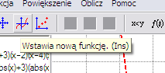
- zainstalować program graph;
- po uruchomieniu wprowadzić przepis funkcji

- i sprawdzić z wykonanym wykresem;

